**Demo and Retrospective Template**

**Demo**

* Status of the software to be developed – summary

Wasted too much time on the database.

Far behind the plan

* Icon of the app

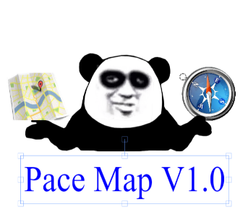

* 3-5 screenshots
* 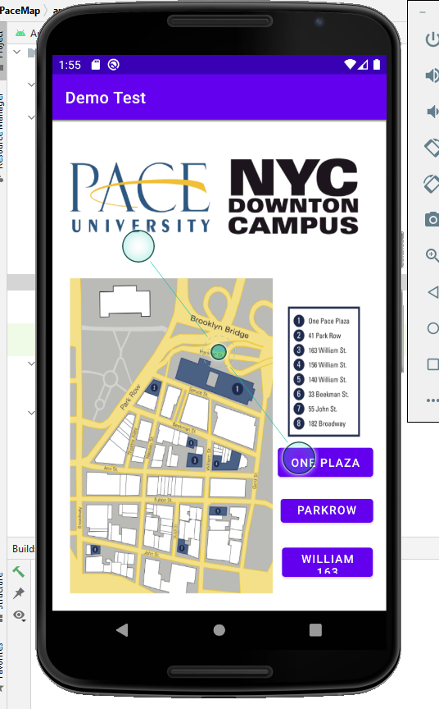 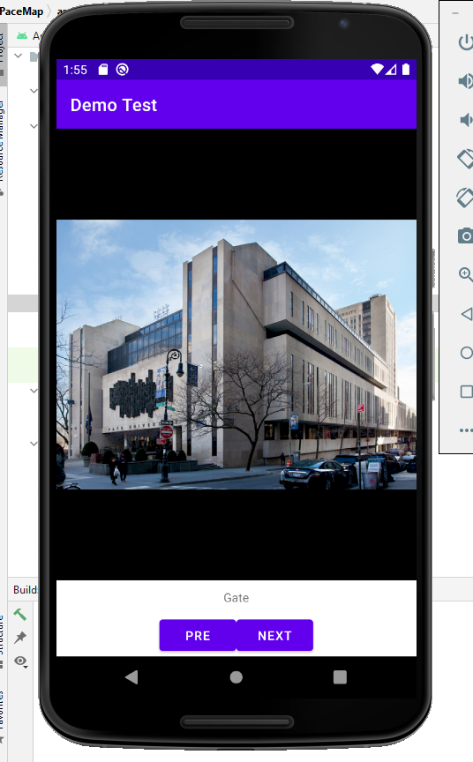 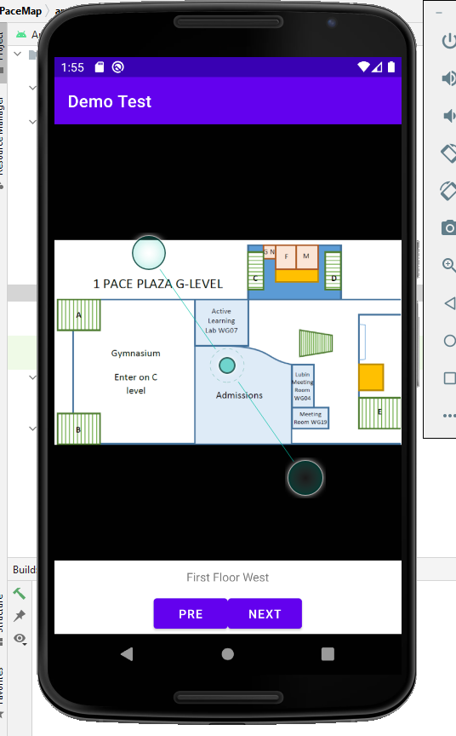

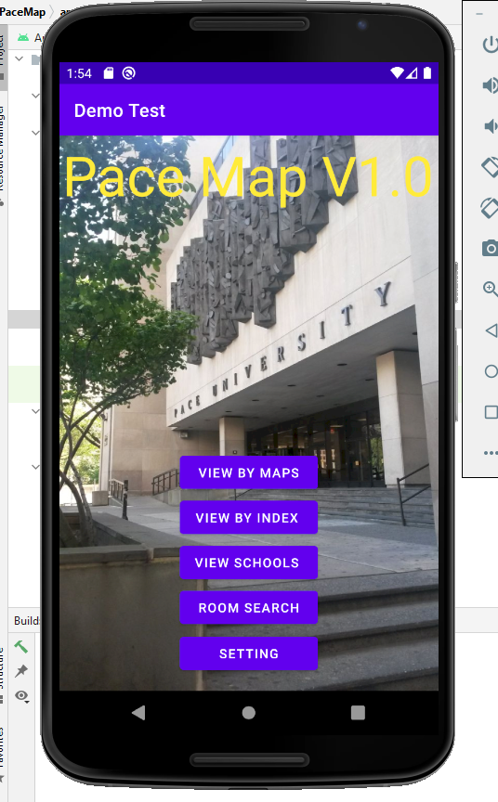

* Video demo of the application (YouTube link)

N/A

* Apk, link or equivalent

Please see the github.

https://github.com/paceuniversity/cs389f2021team9

**Retrospective**

* Sprint goal

Planned: US1 US2 US8 US10 US11 US12 US14.

* Number of stories planned versus implemented

7/1

* Planned versus actual velocity

7/2

* Sprint retrospective written summary
  + What should the team start doing?

* + What should the team stop doing?

Waste time on hard part.

* + What should the team continue doing?

Use another way to replace the hard part

* Status of the evolution of the Product Backlog

One done, one need to be added.

* Burndown chart for the sprint
* Statistics from GitHub